Summing up

3 + 2 = 5, 2 + 2 = 4, 1 + 2 = 3

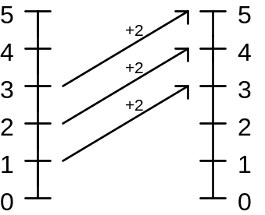We can show this on a diagram using two parallel number lines.

1. Draw a diagram to show 3 + 3 = 6, 2 + 3 = 5, 1 + 3 = 4.
How could you extend the number lines to show negative numbers? Extend as far as –5.
Continue the patterns that your arrows make. Use this to find the answers to
0 + 3, ⁻1 + 3, ⁻2 + 3, ⁻3 + 3, ⁻4 + 3, ⁻5 + 3.

2. Draw a diagram to show 3 + 3 = 6, 3 + 2 = 5, 3 + 1 = 4, 3 + 0 = 3. You should get a different pattern this time.
Continue the pattern that your arrows make and use this to find 3 + ⁻1, 3 + ⁻2, 3 + ⁻3, 3 + ⁻4.
Use these answers to find a rule for abbreviating 3 + ⁻1, 3 + ⁻2,…(ie. Find another way of writing 3 + ⁻1 so that you get the right answer without drawing a diagram.)

3. Repeat the exercise for 4 – 2 = 2, 4 – 1 = 3, 4 – 0 = 4, and extend the pattern to find answers for 4 - ⁻1, 4 - ⁻2, 4 - ⁻3.
Find a rule for abbreviating 4 - ⁻2.

- You should have found two rules. One for adding a negative number and one for subtracting a negative number. Use these to find:

- 2 + ⁻1 - 9 - ⁻3
- 4 - ⁻4 - 2 - ⁻8
- 5 + ⁻2 - 14 + ⁻7

Extension

Try and find the correct answers for these. Explain your reasoning.

- 3 + ⁻5 - -3 + ⁻2
- 4 + ⁻9 - 9 + ⁻15
- ⁻2 - ⁻3 - ⁻4 - ⁻5

